Harper’s Ferry Auto Club
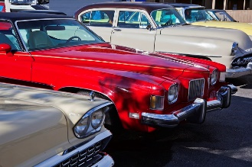

Third Annual Charity Event

Classic Car Show
Friday, May 19 | 6:00 pm – 10:00 pm
Saturday, May 20 | 8:00 am – 7:00 pm
Cold Spring Park | Harper’s Ferry, West Virginia
Registration categories:
- Antique: Cars from the 1930s and earlier.
- Vintage: Cars and trucks from 1940 to 1960.
- Modern Classic: Limited-edition, luxury, and distinctive cars, trucks, and motorcycles from 1960 and later.
- Custom: Customized vehicles from all eras, including exotic vehicles such as racing cars. Special registration is required.
Registration is $18 for custom vehicles and $15 for all other vehicles. All proceeds go to the Harper’s Ferry Charitable Foundation.
